

|  |
| --- |
| UK Fuel Prices & Road Accident Analysis NameDate: April 26 2023**Data** url: <https://www.gov.uk/government/statistical-data-sets/reported-road-accidents-vehicles-and-casualties-tables-for-great-britain%23reported-road-accidents-ras10>  url: <https://www.kaggle.com/datasets/benten867/uk-fuel-price-weekly-statistics20032020>  This data shows detailed analysis of UK Reported Road Accidents from 2000- 2022 and the price fluctuations. Data represents the actual figure of Road Accident Statistics and price fluctuations. |
| Page 1 |

## **Dashboard 1:**

**Fuel Price Trends: Petrol vs Diesel 2003-2022:**

The audience, which includes consumers, companies, and policymakers, gains useful information from the examination of fuel and diesel prices from 2003 through 2022. The line graph illustrates the trend in fuel and diesel prices over time, demonstrating how they have changed over time. The bar chart makes it simpler for the audience to understand the relative costs of the two fuels by providing a visual comparison between the prices of petrol and diesel for the same time period. The third graph offers a more up-to-date perspective of the trends in fuel price by comparing the prices of petrol and diesel over the previous two years (2020–2022).

For people and businesses who use petrol and diesel for transportation, this dashboard is helpful since it explains how the cost of these fuels has changed over time. The dashboard also offers useful insights for decision-makers, who can utilize this data to decide on gasoline price policies and regulations. The audience may improve their budgeting and gasoline consumption decisions by analyzing this data, and they can also learn more about the variables that affect fuel pricing.

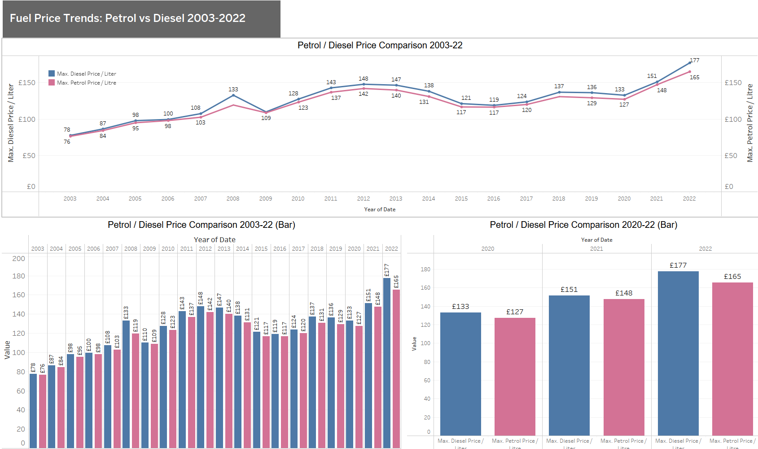

## **Dashboard 2:**

**Fuel Price Trends: Petrol vs Diesel 2003-2022:**

This dashboard offers information on the average price disparities between petrol and diesel for the past 19 years (from 2003 to 222) as well as the respective VAT rates for both fuels during this time. This information can be used by the audience to comprehend the trend in fuel costs over time and how VAT affects fuel prices. Additionally, based on historical trends, they can utilize this research to plan their fuel expenditures for the next years. Overall, everyone interested in tracking and comprehending gasoline prices and their changes over time, including consumers, corporations, and policymakers, will find this dashboard to be a useful tool.

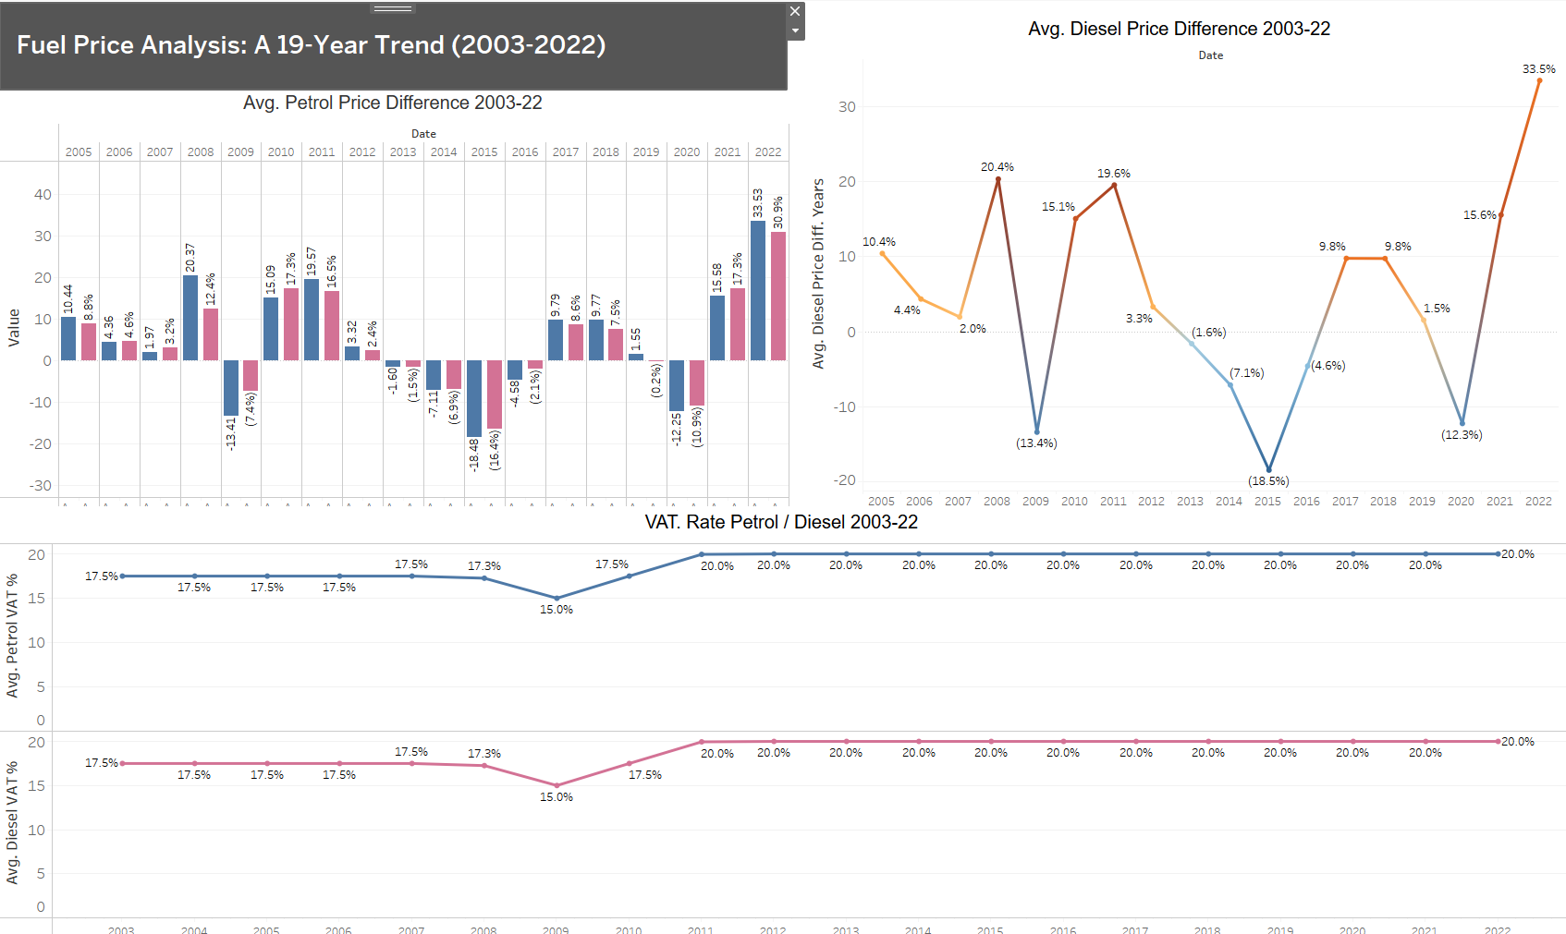

## **Dashboard 3:**

This dashboard offers information on historical duty rates for petrol and diesel as well as trends in fuel pricing. The audience may grasp the trend in fuel costs and make wise decisions regarding fuel usage by viewing Chart 1's average fuel price difference over the previous five years. The duty rate for petrol and diesel is shown in Chart 2 for the period of 2003 to 2022, allowing viewers to observe how the rates have changed over time and how this has affected the price of fuel as a whole.

The weekly petrol and diesel costs for 2022 are shown in Chart 3, which is helpful for tracking the prices in real-time and budgeting for fuel expenses accordingly. This dashboard is beneficial for fuel consumers, businesses, and policymakers who need to understand the dynamics of fuel prices and duty rates.

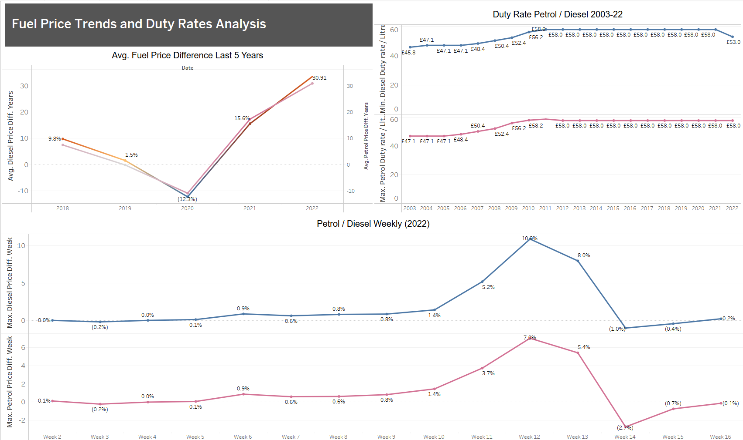



## **Dashboard 3:**

This dashboard offers information on historical duty rates for petrol and diesel as well as trends in fuel pricing. The audience may grasp the trend in fuel costs and make wise decisions regarding fuel usage by viewing Chart 1's average fuel price difference over the previous five years. The duty rate for petrol and diesel is shown in Chart 2 for the period of 2003 to 2022, allowing viewers to observe how the rates have changed over time and how this has affected the price of fuel as a whole.

The weekly petrol and diesel costs for 2022 are shown in Chart 3, which is helpful for tracking the prices in real-time and budgeting for fuel expenses accordingly. This dashboard is beneficial for fuel consumers, businesses, and policymakers who need to understand the dynamics of fuel prices and duty rates.



## **Dashboard 4:**

Three charts are displayed on the dashboard: a bubble chart showing the breakdown of gasoline prices per liter, pie charts showing the breakdown of diesel prices per liter, and both. The percentage breakdown of the major factors affecting the cost of gasoline and diesel per liter is displayed in pie charts. The bubble chart, which takes into account numerous aspects including location, taxes, and other costs, aids in understanding the price changes of gas over time.

The audience can comprehend the many elements and how they affect fuel prices thanks to the dashboard's visual representation, which makes it easier to make wise selections when buying fuel.

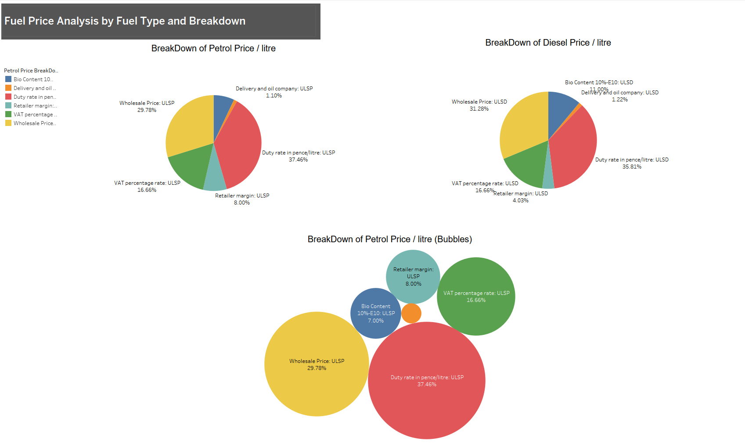

## **Dashboard 5:**

Three visualizations on the dashboard offer information on trends in inflation and fuel prices. The first graph, a bubble chart, shows a breakdown of the cost of fuel per liter. The second graph, a line graph, shows the CPI% of inflation from 1997 to 2022. The third graph uses line charts to compare the cost of crude oil with that of petrol and diesel from 1988 to 2022.

Anyone interested in understanding the trends and variations in fuel prices over time can benefit from the information on the dashboard. The first figure assists in comparing the pricing of petrol and diesel, while the second chart sheds light on historical inflation trends. A greater understanding of the relationship between fuel costs and crude oil prices may be gained by comparing the prices of petrol and diesel with those of crude oil in the third chart. The dashboard can help consumers, traders, and politicians make educated judgements about fuel pricing.

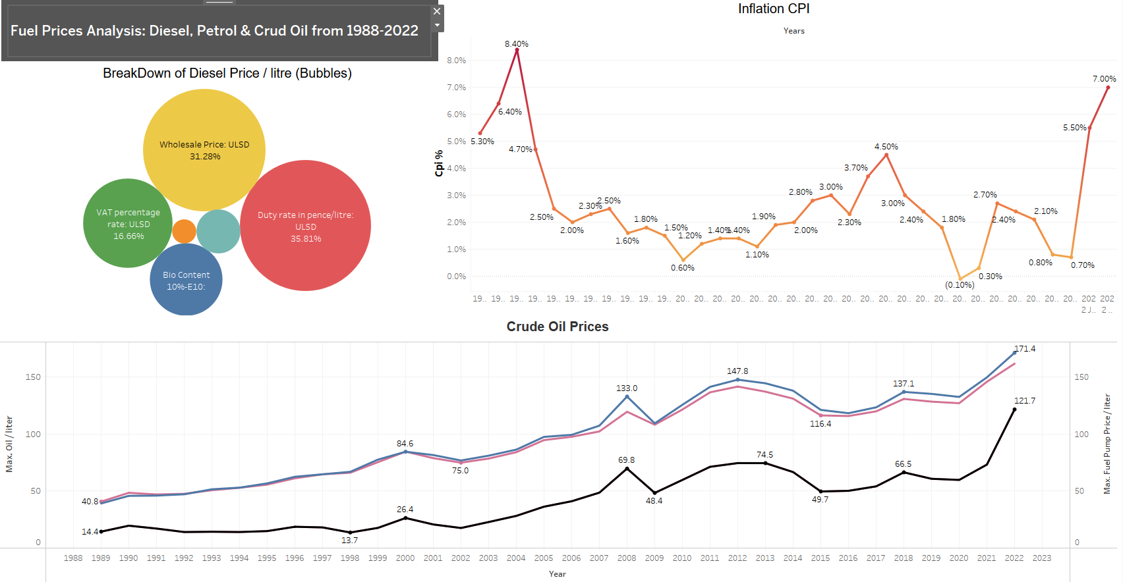

## **Dashboard 6:**

An overview of fuel prices in the UK over the last three decades is given by this dashboard. Chart 1 displays the main fuel prices for petrol and diesel from 1990 through 2022, excluding tax and duty. Chart 2 outlines significant occasions that affected petrol prices over this time, including changes in VAT rates, fuel tax escalators, and international occurrences like the Gulf War.

The total duty taxes on fuel from 1990 to 2022 are shown in Chart 3, which illustrates how taxes have affected the price of fuel in the UK as a whole. Anyone interested in following fuel prices and comprehending the variables that affect them will find this dashboard to be helpful. Making wise judgements about energy usage, budgeting, and policy formulation can be aided by it for people, corporations, and legislators.

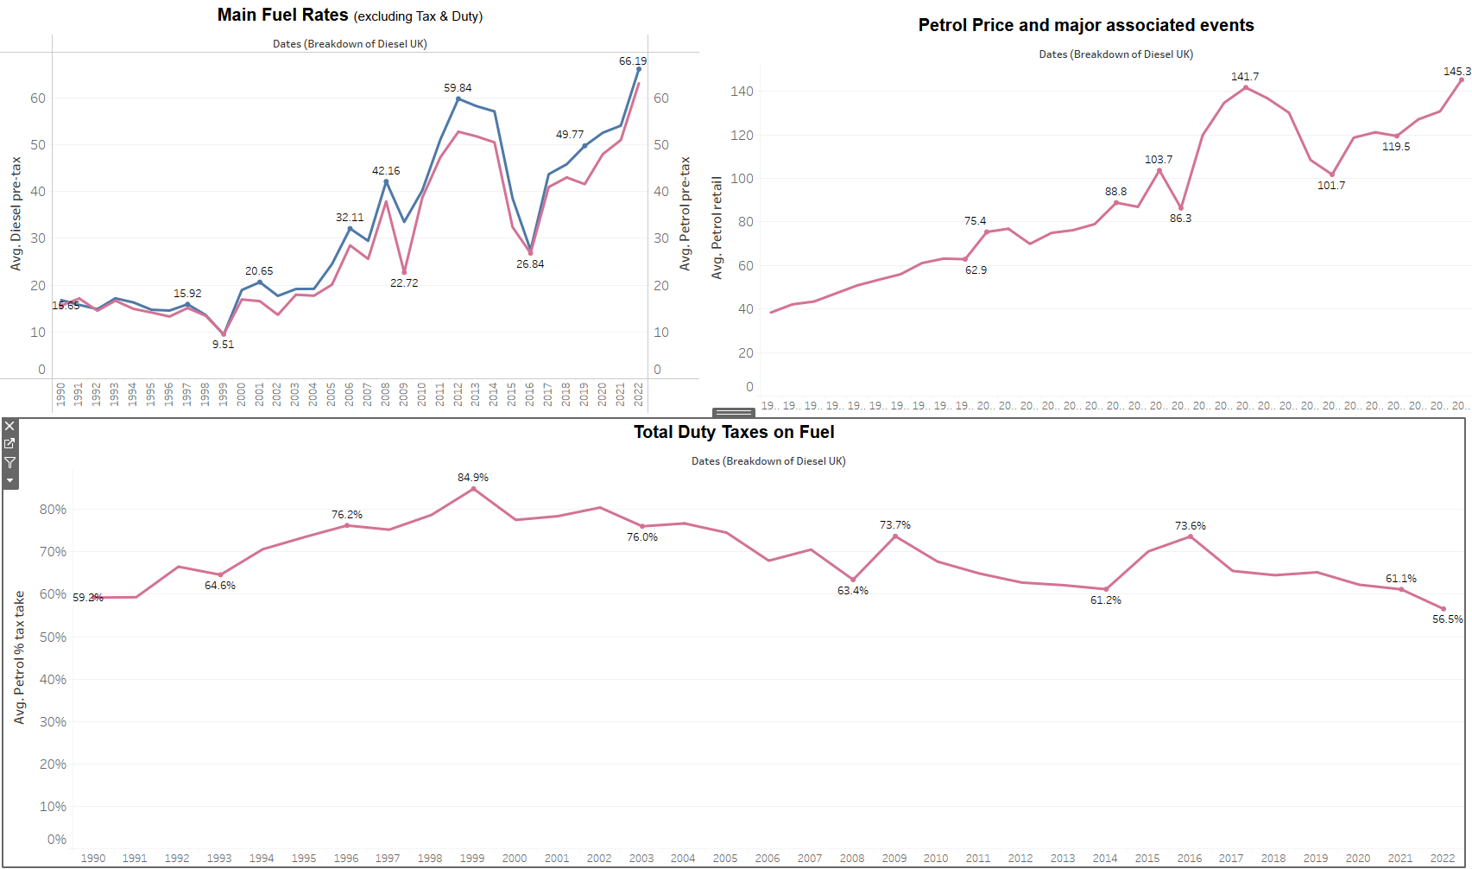

## **Dashboard 7:**

This dashboard offers a thorough examination of developments in gasoline demand, taxes, and pricing in the UK and EU. The first graph compares the cost of petrol and diesel in the UK and the EU using a dual bar chart. The second graph is a cluster diagram that contrasts the gasoline taxes levied by the UK with different EU nations. The third graph, an area chart, shows the trends in the demand for petrol and diesel in the EU and the UK.

This dashboard will assist the audience in comprehending the variations in fuel costs and taxes between the UK and the EU, as well as the patterns of demand for petrol and diesel in each region. Policymakers, fuel suppliers, and consumers may find this information relevant.

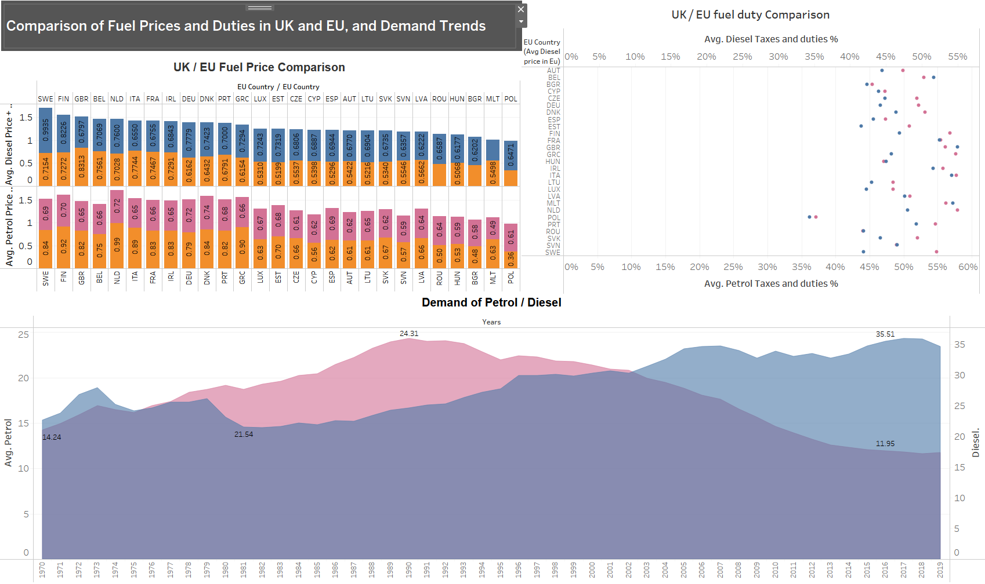

## **Dashboard 8:**

Three charts on this dashboard offer insights into the analysis of fuel costs and inflation rates. The first graph is a bar chart that shows the rate of inflation in the UK's various regions from July 2021 to March 2022. The price difference between petrol and diesel each week in 2022 is depicted in the second graph, which is a bar chart. The final graph compares the fuel duty rates for petrol and diesel in a line format.

The audience who is interested in following the inflation rate and fuel prices would find this dashboard to be helpful. The audience can better comprehend how the UK's various regions are affected by inflation by looking at the inflation rate bar chart. People who want to follow fuel prices and adapt their fuel purchases accordingly can benefit from knowing the weekly change in fuel prices. Finally, those who want to understand how the government levies taxes on fuels can gain useful insights from comparing gasoline duty rates.

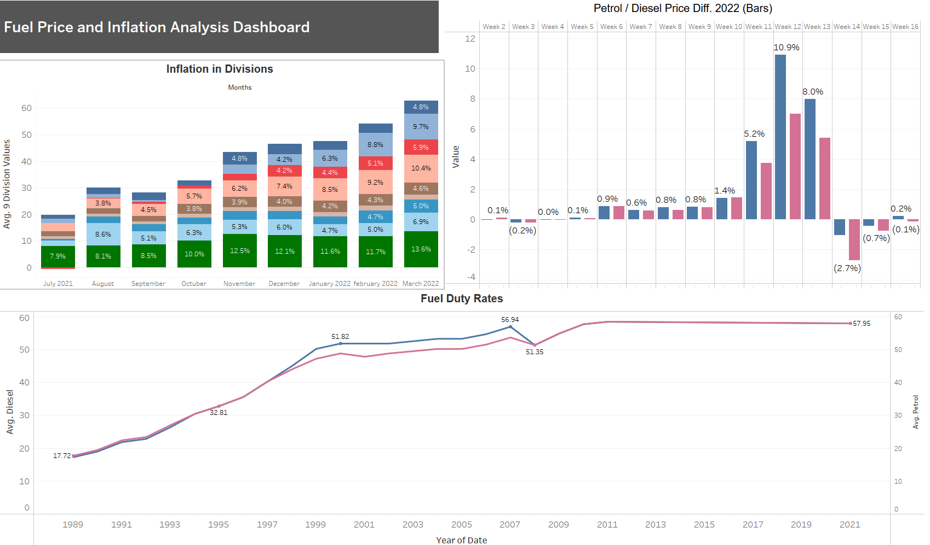

## **Dashboard 9:**

In this Dashboard, Chart 1 provides a quick visual comparison of the current price with the historical average by displaying a bullet graph showing the average petrol price difference from 2003 through 2022. People who want to track trends in gas prices and choose their fuel purchases wisely can benefit from this information.

Viewers may see the recent trends in fuel price in Chart 2, which displays a line graph of the average fuel price difference over the previous five years. People can use the chart to make an accurate assessment of the trends in fuel prices over time and to arrange their budgets accordingly.

A line chart depicted in Chart 3 examines the weekly price difference between petrol and diesel from 2003 to 2022. The graph enables users to comprehend how the cost differential between petrol and diesel has evolved over time. Businesses and individuals who depend on fuel for their operations will find this information useful in deciding whether to buy petrol or diesel.

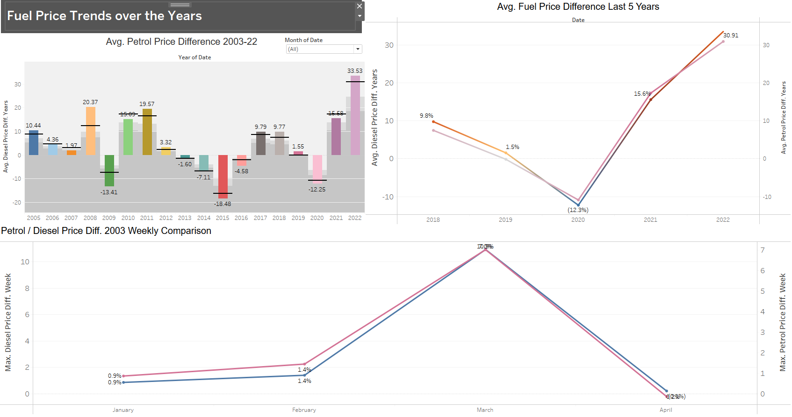

## **Dashboard 10:**

A bar chart that aids in analyzing mortality by age group per million from 2013 to 2020 is shown in Chart 1. In order to design targeted road safety regulations and programmers, it is helpful to determine which age group is most susceptible to accidents on the road.

The breakdown of fatalities by types of road users, including pedal bicycles, motor vehicles, motorbikes, and pedestrians, is shown in Chart 2 as a pie chart. It gives information on the main reasons why accidents happen on the road and can assist in the development of policies to lower the number of fatalities among these road users.

Line charts are useful for comparing traffic deaths by road user from 2000 to 2020, as shown in Chart 3. This comparison can assist policymakers in creating targeted initiatives to increase road safety by highlighting any patterns or trends over time.

Overall, the dashboard offers a thorough study of traffic fatalities by age group and road user, which can help researchers, policymakers, and the general public comprehend the nature of traffic accidents and create mitigation plans.

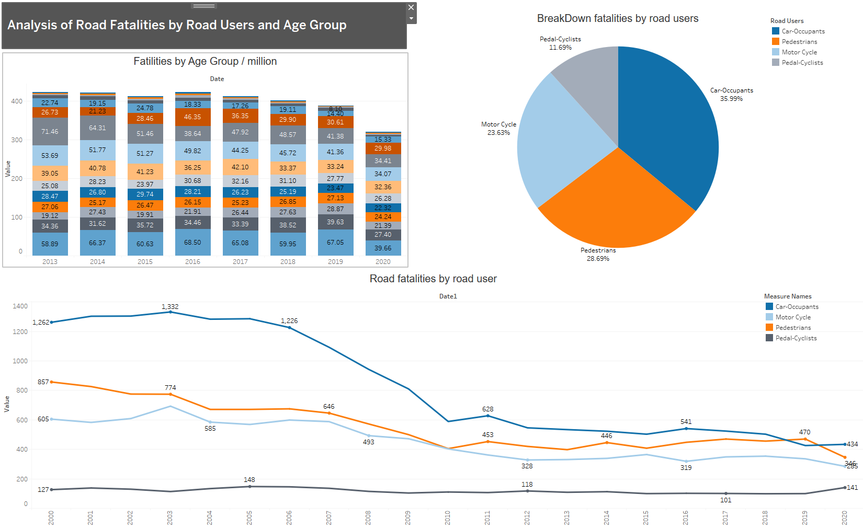

## **Dashboard 11:**

In this dashboard, chart 1: From 2013 to 2020, a line graph depicts the number of fatalities by kind of route (urban, rural, and motorway). This analysis clarifies the prevalence of traffic fatalities on various types of roads and can assist decision-makers in determining the best course of action for road infrastructure and safety measures.

Chart 2: The cost of traffic collisions is depicted as a series of bar charts, including fatal, minor, accident-related damage, serious, and non-fatal. This research can assist policymakers in allocating resources to increase road safety and also help the audience comprehend the economic cost of traffic accidents.

Chart 3: The speed limit-based casualties are displayed in a bar chart. The results of this analysis can assist policymakers in determining the right speed restrictions for various types of roads and aid the public in understanding the relationship between speed limits and traffic fatalities.

## **Dashboard 12:**

The percentage of accidents that happened in various weather situations, such as fog, rain, snow, etc., is shown in this graph. This analysis enables the audience to comprehend how weather conditions affect driving safety and motivates them to adopt the appropriate safety measures.

The number of pedestrians and car occupants killed in traffic accidents from 2005 to 2010 is shown in this composite bar graph. It aids the audience in comprehending the dangers linked to various forms of transportation and can be helpful to legislators when developing safety regulations.

The number of accidents that happened over time on roadways with and without lamps is depicted in a line graph. The analysis aids the audience in understanding how street lighting affects driving safety and can be helpful to local authorities in determining which locations need more effective street lighting.

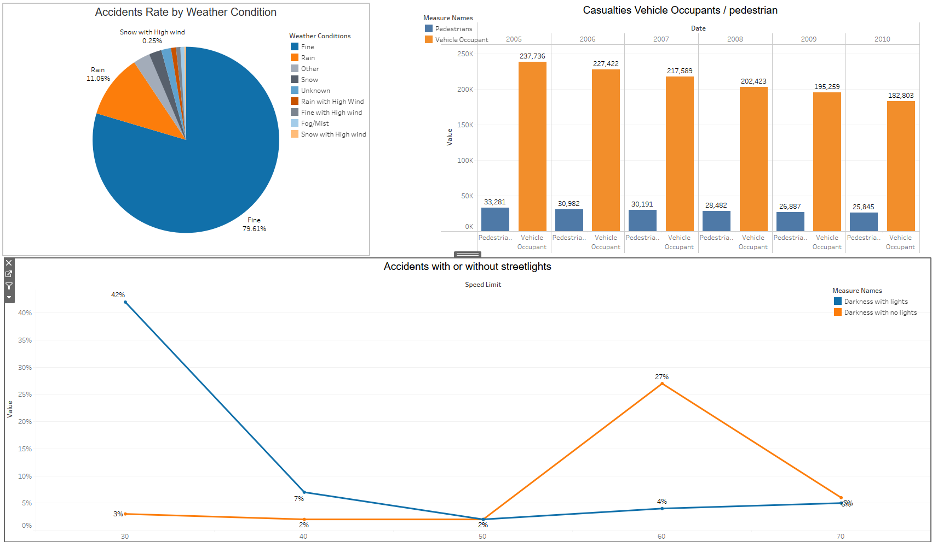

## **Dashboard 13:**

The UK Road network is analyzed in charts 1 and 2. Road classes are depicted in Chart 1 as a pie chart, encompassing motorway, A, B, C, and unclassified A(M). The breakdown of roads into single carriageway, dual carriageway, roundabout, one way, slip road, and unknown is shown in Chart 2. In order to priorities road maintenance, increase road safety, and make well-informed decisions about road infrastructure, these charts offer useful information to politicians and transportation authorities.

In Chart 3, a line chart, fatalities are broken down by age and kind of vehicle, revealing the most vulnerable road users, such as bicycles and pedestrians. To improve road safety and lower the number of traffic fatalities, politicians and transportation authorities must use this information to establish focused policies.

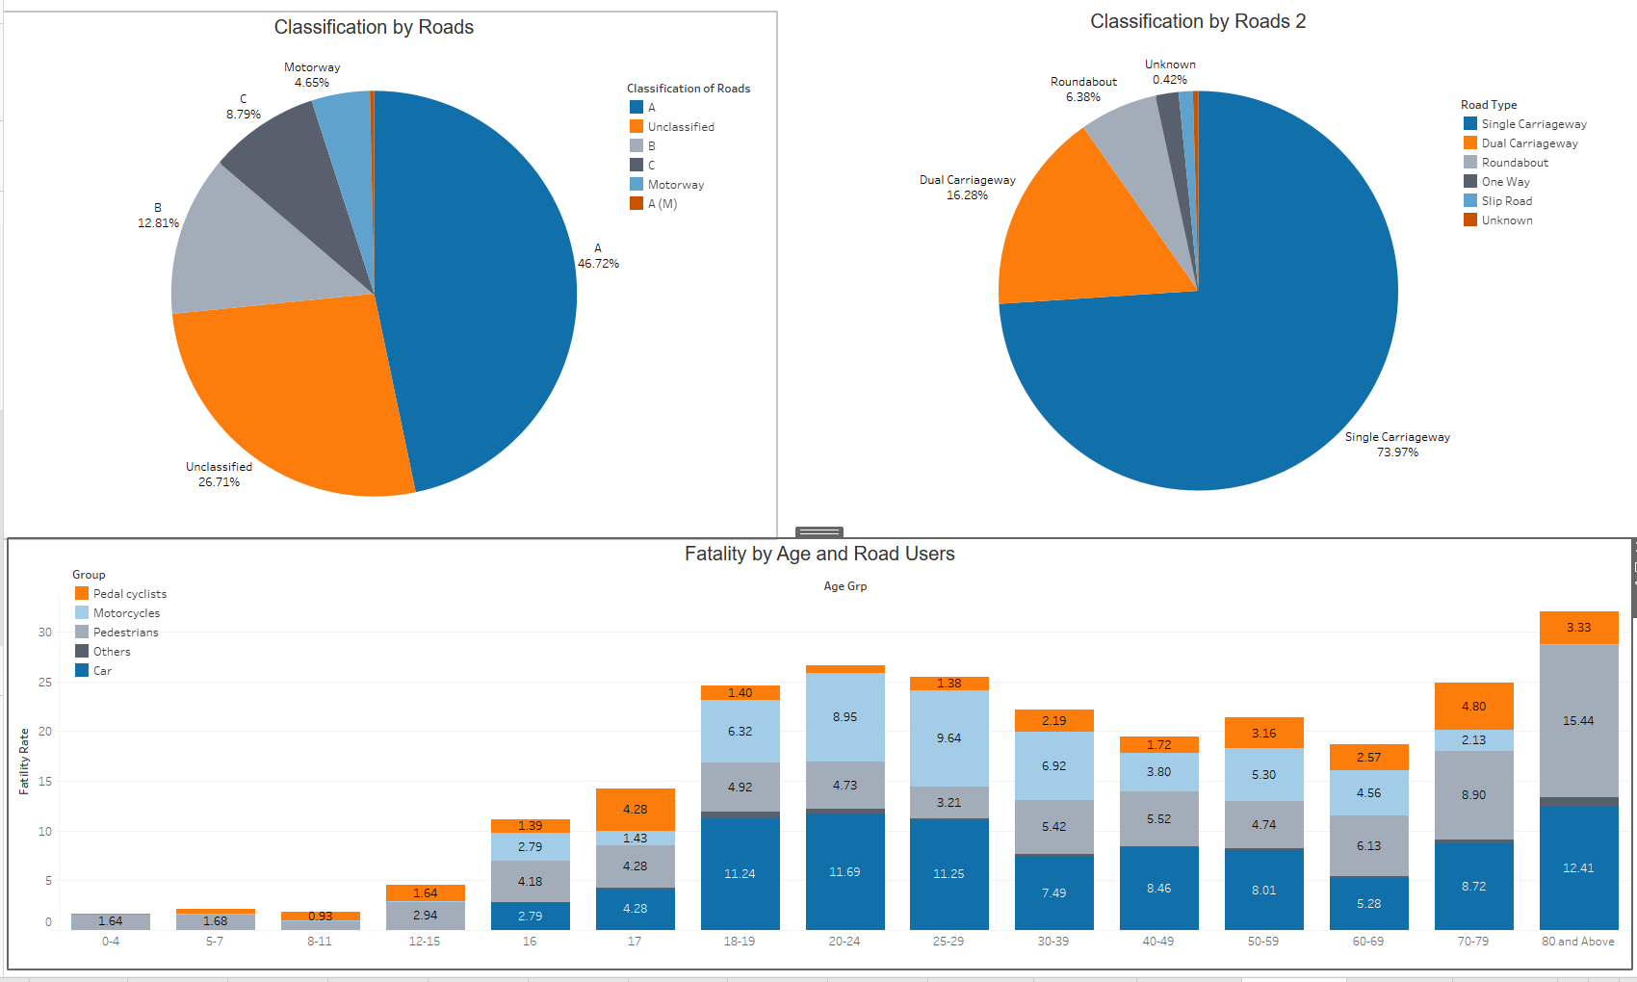

## **Dashboard 14:**

In this dashboard, Chart 1: The audience will have a comprehensive knowledge of the financial impact of road accidents in different categories after seeing the pie chart breakdown of the cost of accidents by several categories, such as fatal, slight, damage by accident, serious, non-fatal accidents.

A better understanding of the types of road infrastructure that are most likely to result in accidents can be gained from Chart 2's bar chart analysis of casualties by road infrastructure, such as bus shelters, central barriers, in water, etc. Policymakers can use this knowledge to increase road safety measures.

Chart 3: The audience will better understand the dangers and hazards linked with various road infrastructures and how to avoid them by studying the three maps in which we analyses accident categories that will be fatal, such as trees, road signs, and entered ditches. In order to take measures to increase road safety, this information will be helpful to drivers, legislators, and law enforcement organizations.

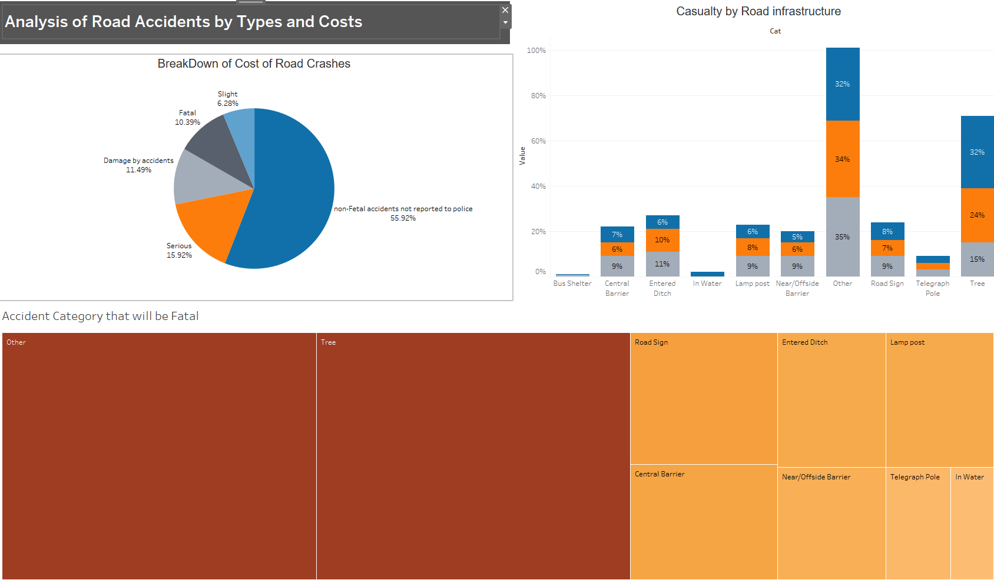

## **Dashboard 15:**

Chart 1: Bubble chart displaying the category of accidents that will be considered serious. The accident categories that are most likely to cause significant injuries or fatalities are summarized in this graph.

Chart 2: A bar graph displaying the category of accidents that will be minor. Understanding the many kinds of accidents that are less severe and do not cause serious injuries or fatalities will be made easier with the aid of this chart.

Chart 3: A bar graph detailing the cost of traffic accidents from 2015 to 2020. This graph will show how much accidents cost in terms of vehicle damage, infrastructure costs, and medical costs. The audience will benefit from understanding the financial cost of traffic accidents and the necessity of preventative actions.

In general, this dashboard will assist the audience in comprehending the seriousness and expense of traffic accidents, which will aid in raising awareness and promoting the adoption of preventative measures to lessen the frequency of accidents on the road.

